E-Project: ***Nextag***

*Purses and Wallet*

Developer Guide

|  |  |  |
| --- | --- | --- |
| **Supervisor:** | Sir Owais Ahmed Khan |  |
| **Batch:** | 2306c2 |  |
| **Group:** | C |  |
| **Serial no.** | **Enrollment number** | **Student Name** |
| 1. | Student1480294 | MARIA AQEEL |
| 2. | Student1480184 | ZAINAB RASHID |
| 3. | Student1482521 | AQSA IQBAL |
| 4. | Student1482528 | SANA |
| 5. | Student1482523 | RAMSHA BAKHT |



E-Project: ***Nextag***

Home Page

*SECTION OF CAR0USEL*

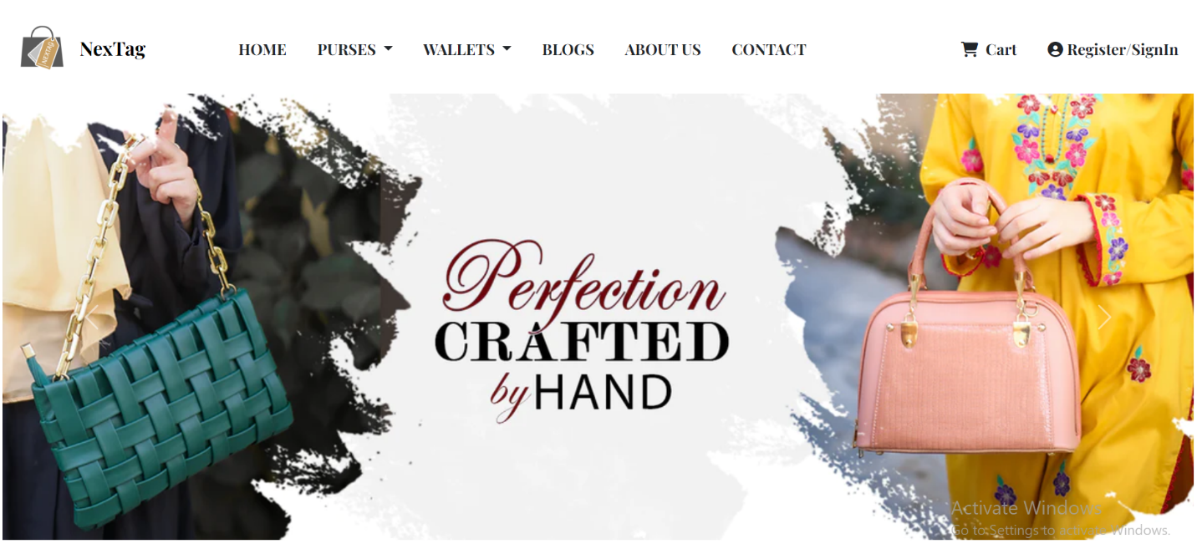

*A purse is typically a small bag, often carried by women, designed to hold personal items such as money, keys, cosmetics, and other small essentials.*

Code of Carousel

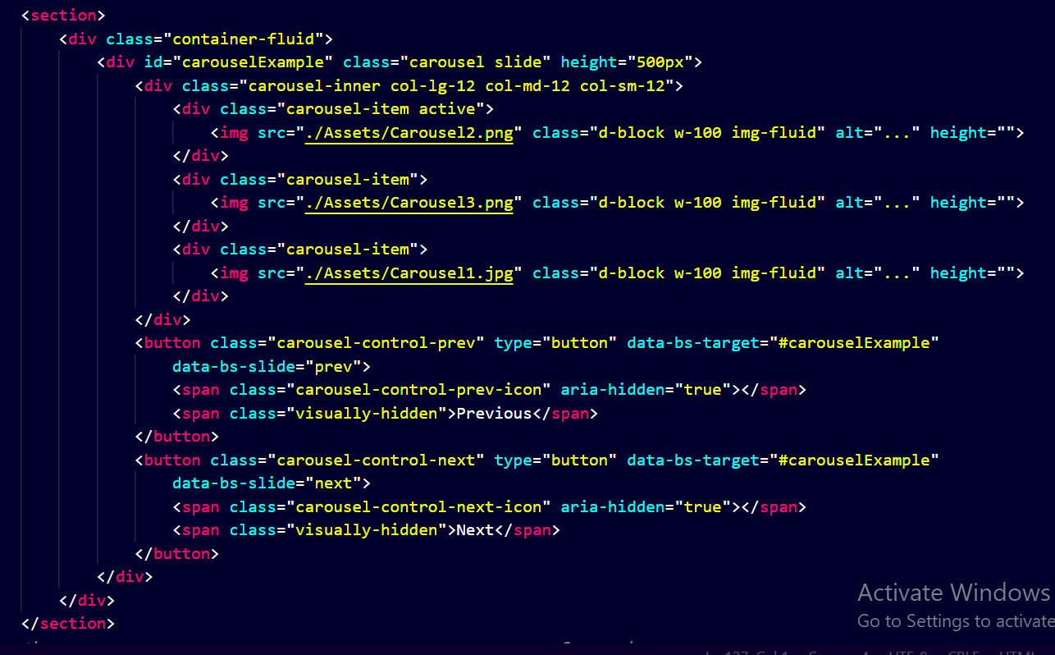

*If a "purse and wallet carousel" refers to a product that organizes or displays purses and wallets in a rotating or carousel-like manner, it could be a functional and aesthetic storage solution.*

E-Project: ***Nextag***

*Section of Banner*

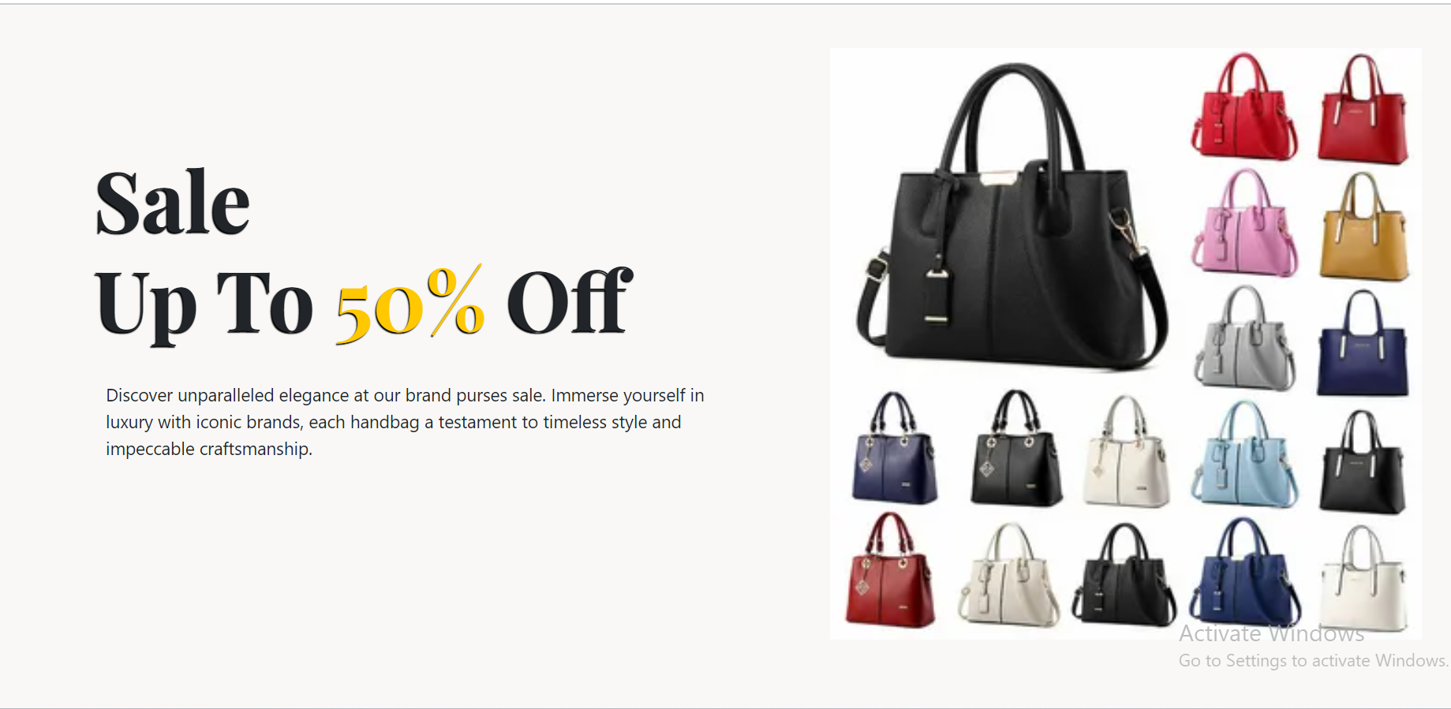

*👛 Hurry in-store or shop online to indulge in the ultimate purse shopping experience. Fashion meets affordability – your perfect bag is just a click away!*

Code of Banner

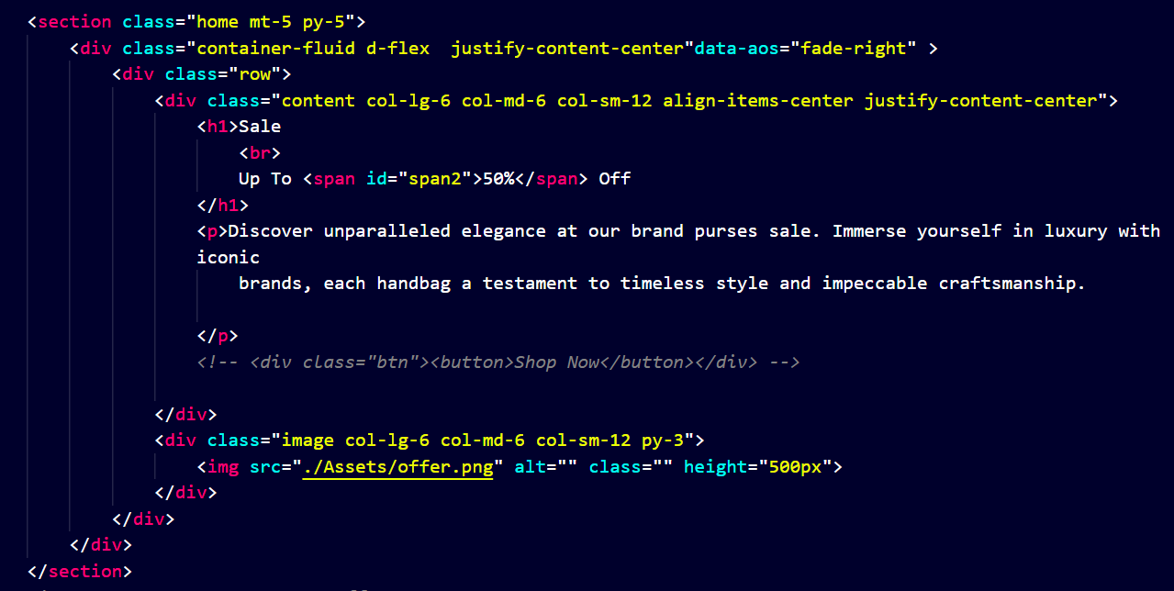

*Our purses seamlessly blend fashion and functionality. Choose from a range of styles and colors that effortlessly transition from day to night*.

E-Project: ***Nextag***

*Section of Arrival*

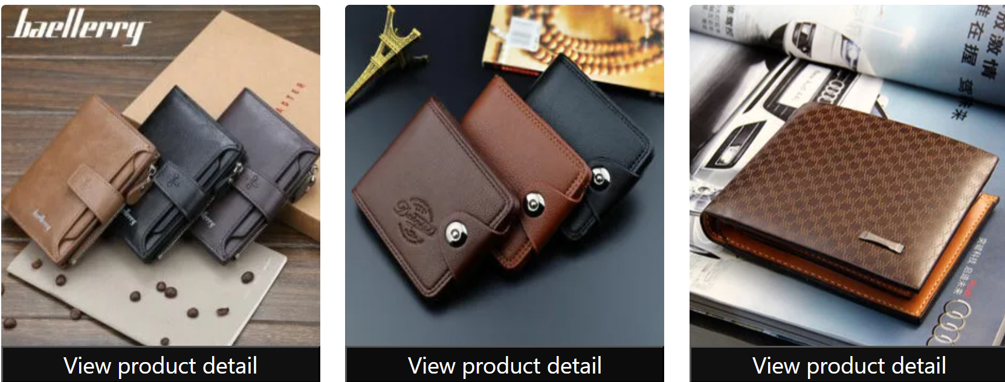

*"Introducing the latest in men's wallet fashion – elevate your everyday with our new arrivals, blending style and functionality in every fold."*

Code of Arrival

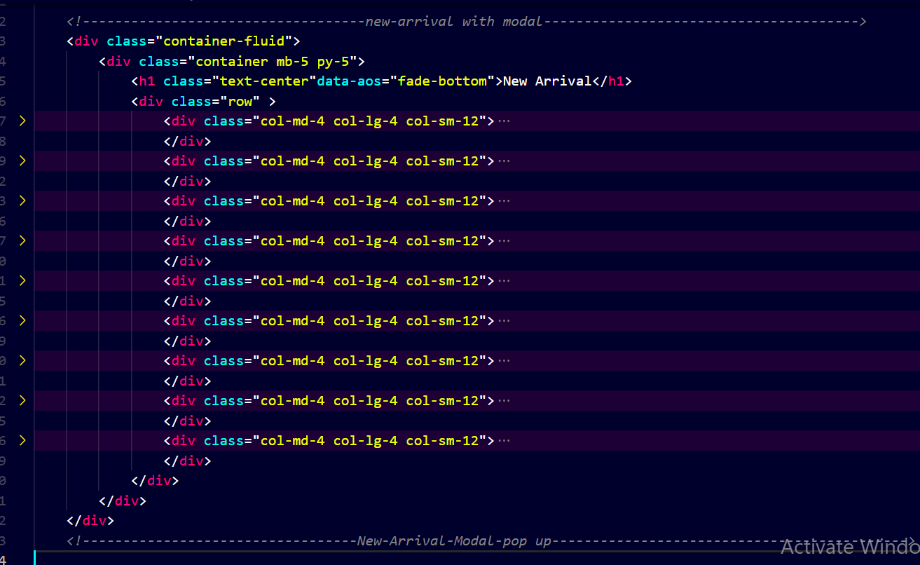

*"Discover unparalleled style with our newest men's wallet arrivals – a fusion of modern design and functionality, making a statement in every pocket."*

E-Project: ***Purse and Wallet***

*Section of Collection*

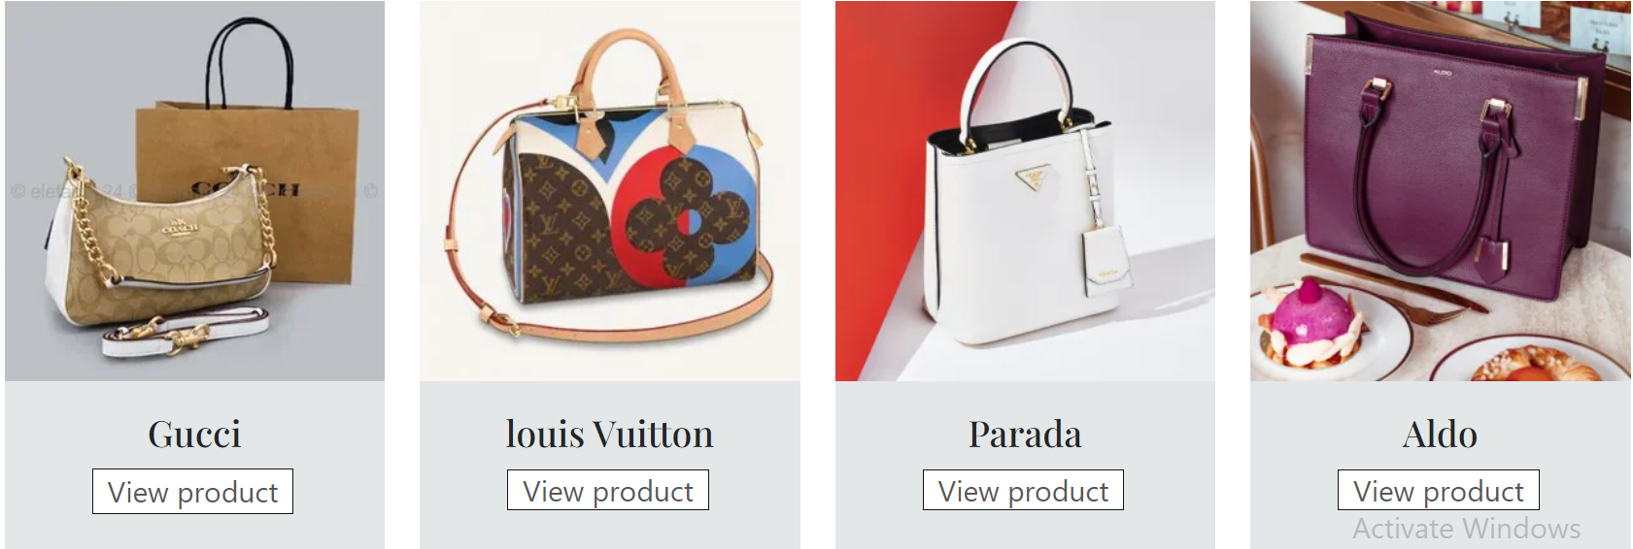

*"Discover unparalleled style with our newest men's wallet arrivals – a fusion of modern design and functionality, making a statement in every pocket."*

Code of Collection

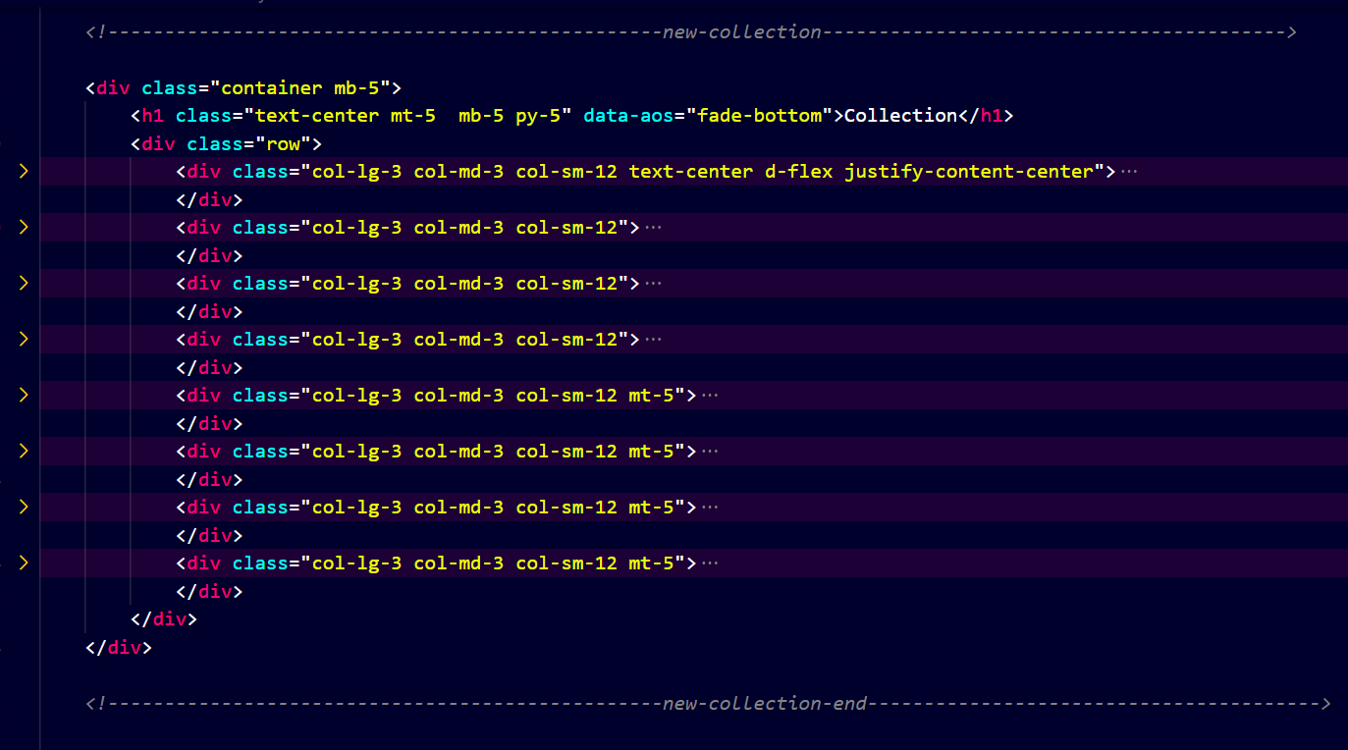

*"Dive into luxury with our latest purse collection. Immerse yourself in a world of timeless designs and modern trends, where each handpicked piece combines style and practicality”.*

E-Project: ***Purse and Wallet***

*Section of Story*

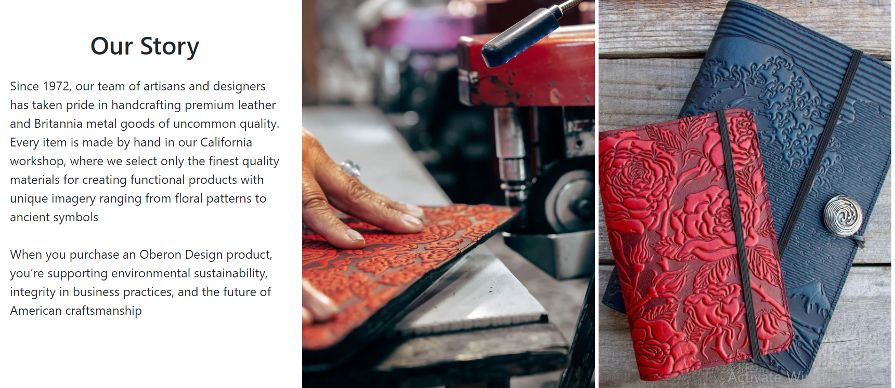

*The story of a purse often begins with the careful selection of materials and the vision of a designer. Skilled artisans then bring these elements together, meticulously cutting and stitching to create the intricate patterns and shapes that define the purse*.

Code of Story

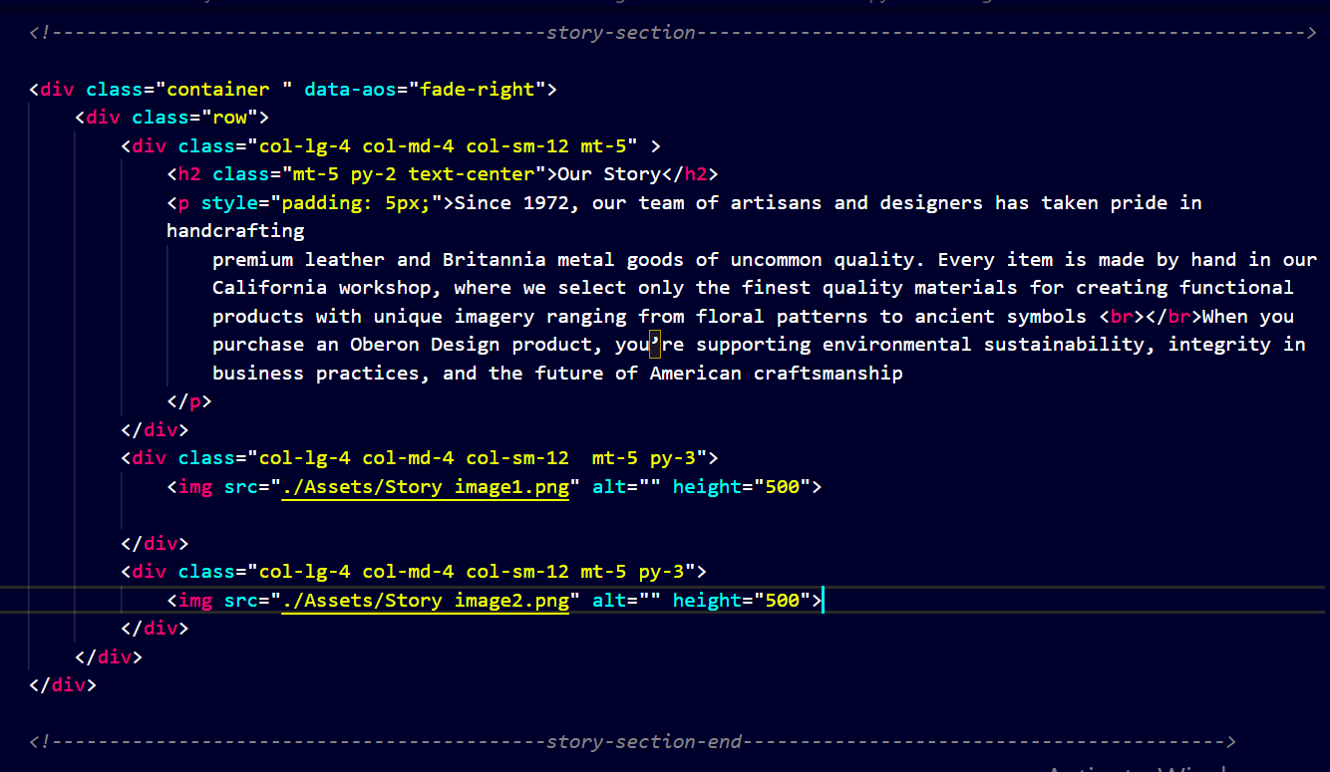

*The journey of a purse is not just about its physical creation; it carries with it the spirit of creativity and the aspirations of those who contributed to its making. From the designer's imagination to the hands of skilled artisans, a purse is more than an accessory — it's a wearable piece of art, ready to accompany its owner on their daily adventures with style and grace.*

*Top of Form*

E-Project: ***Purse and Wallet***

*Section of Brand Logo*

**

*The Louis Vuitton logo features the interlocking letters "LV" in a repeating pattern on a brown background. Fendi's logo is characterized by the double "F" monogram. Gucci's logo often includes interlocking letters "G" in green and red. Chanel's iconic logo consists of interlocked "C" letters in black and white, representing simplicity and elegance.*

Code of Brande Logo

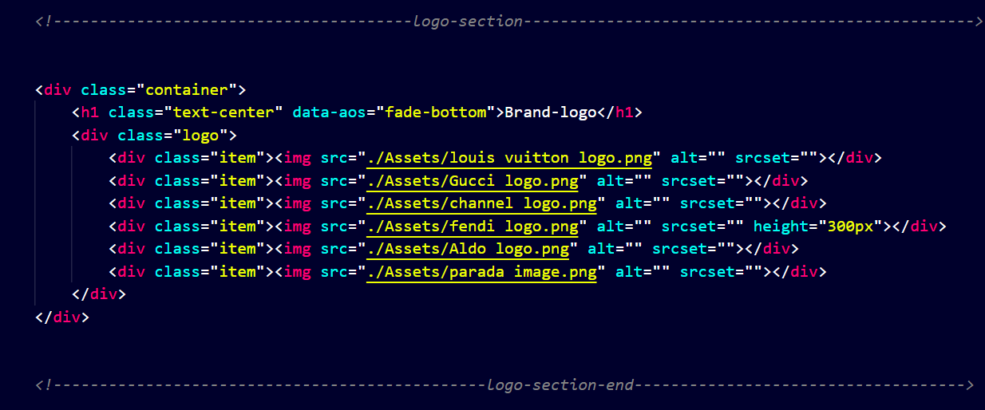

*If you want to include a brand logo description alongside the logo, you can modify the HTML to include a text description*

E-Project: ***Purse and Wallet***

*Section of Footer*

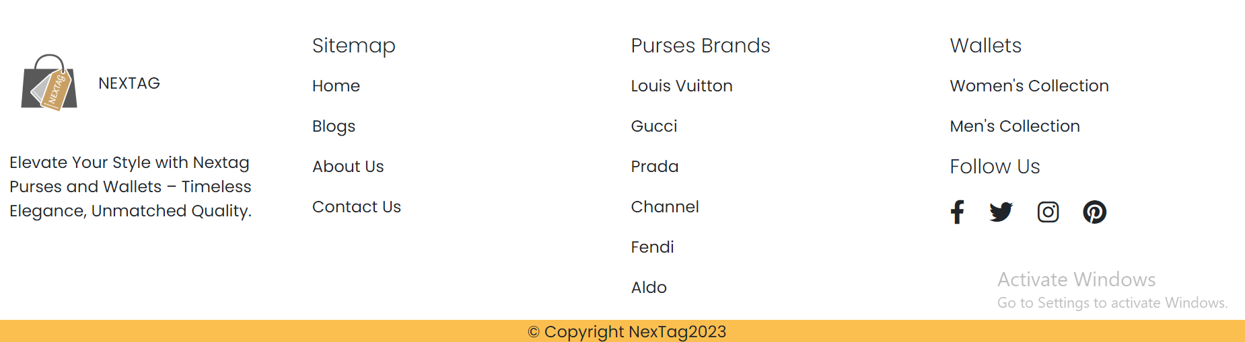

*"Step into style with our exquisite purse collection. Elevate your fashion game with every step you take. Discover the perfect blend of sophistication and functionality*

*Code of Footer*

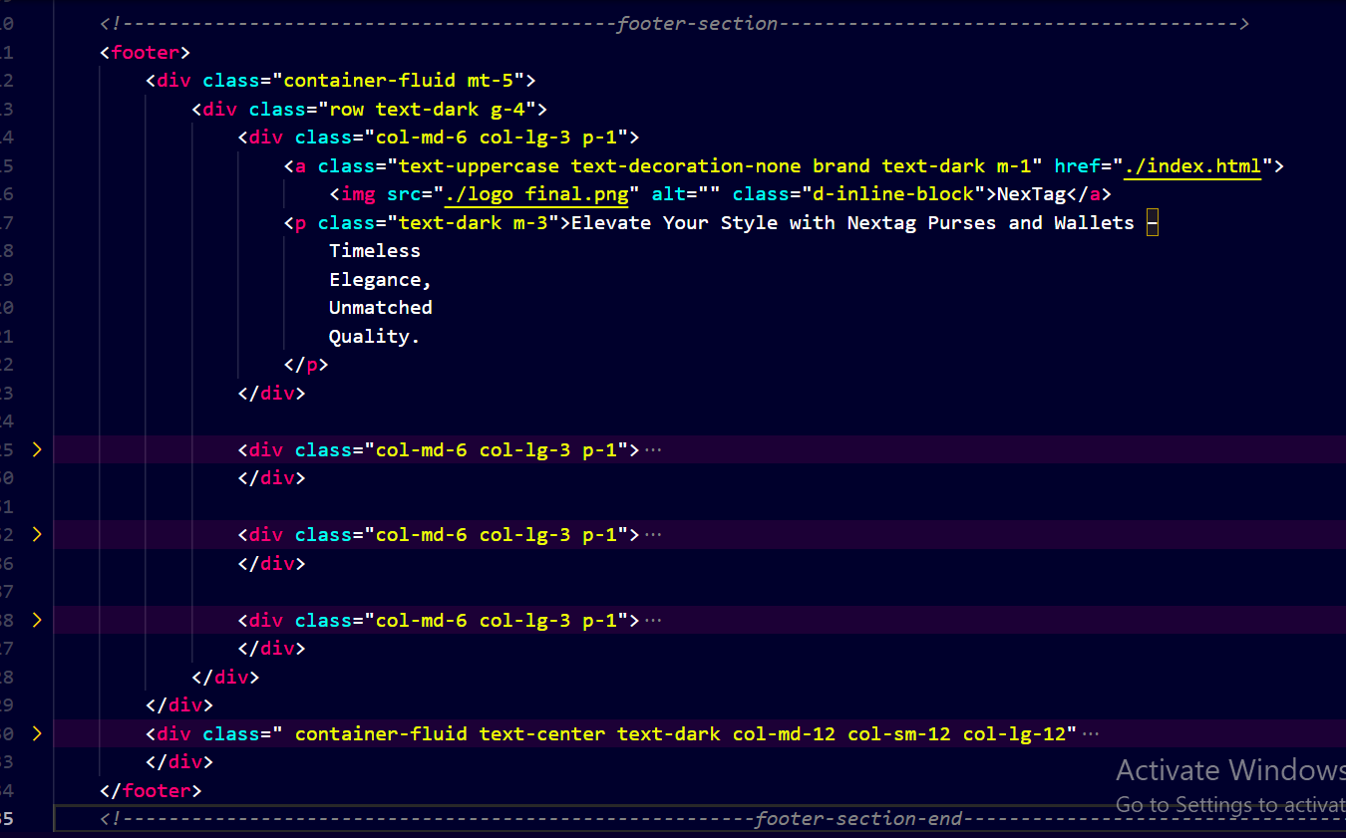

*If you're looking to implement a footer description on a website, you'll typically use HTML for structuring and styling, and CSS for presentation*